UNITS OF MEASUREMENTS

m3 – volume (round up)
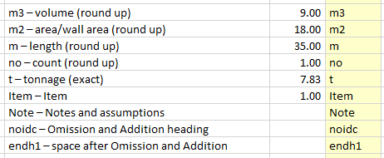
m2 – area/wall area (round up) Sample:
m – length (round up)
no – count (round up)
t – tonnage (exact)
Item – Item
Note – Notes and assumptions
noidc – Omission and Addition heading
endh1 – space after Omission and Addition

NOTE: Display all your quantities in 2 decimal places

